1523. Count Odd Numbers in an Interval Range
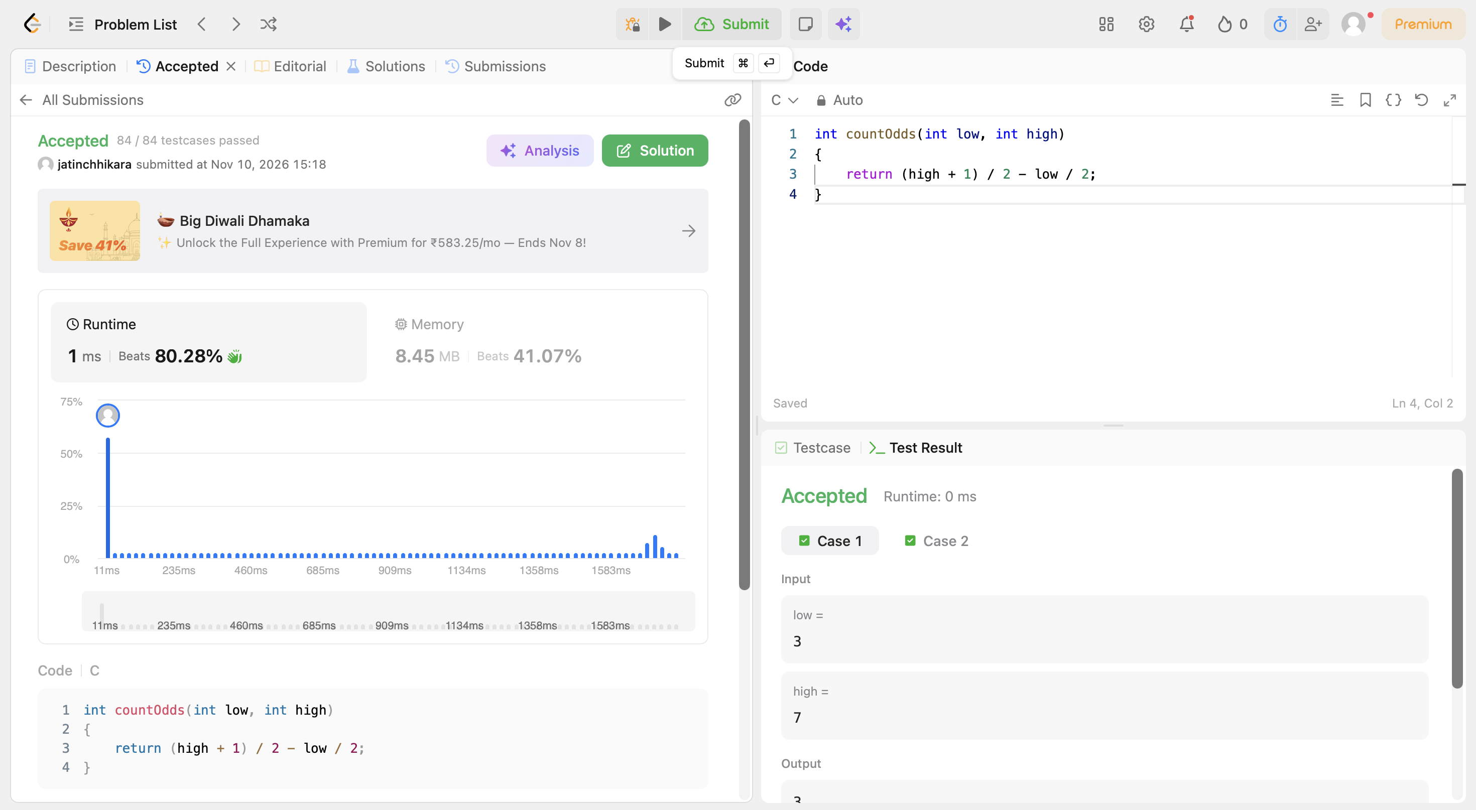
Code:
int countOdds(int low, int high)
{
return (high + 1) / 2 - low / 2;
}

